DOC ZONE: GENERATION BOOMERANG
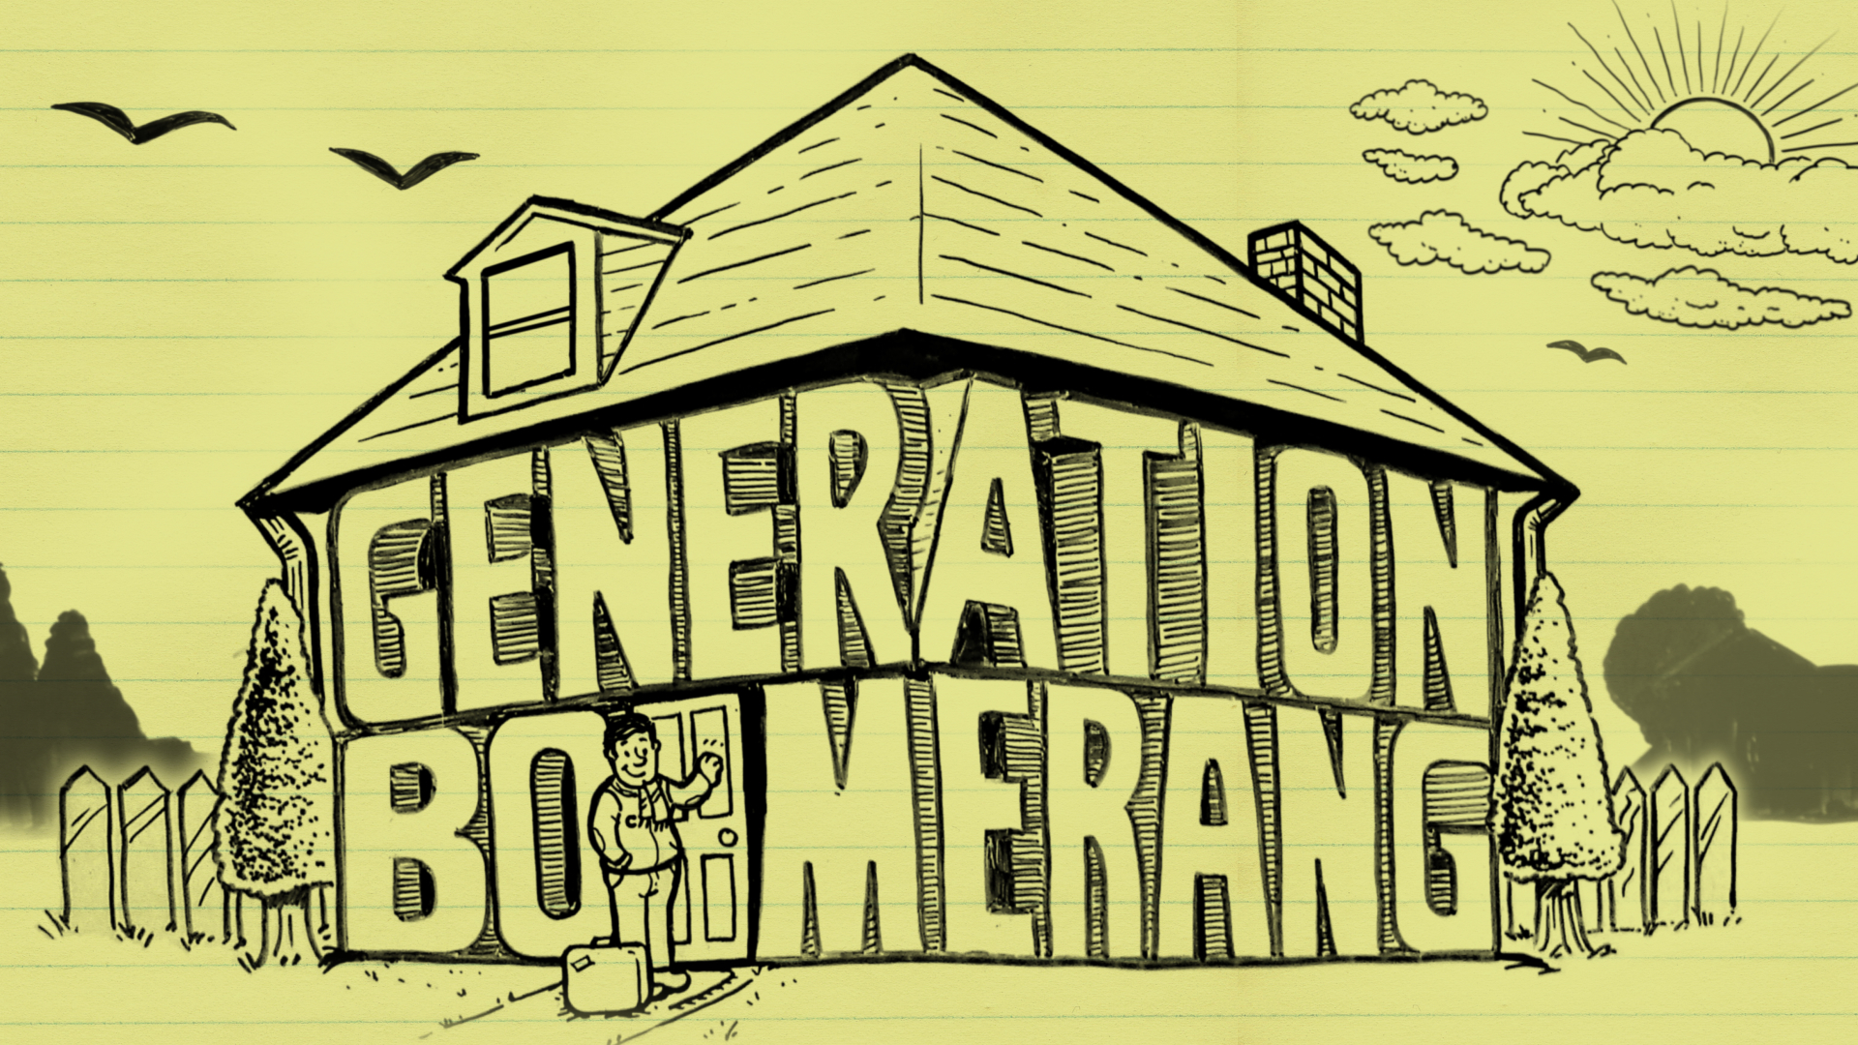
As you watch the documentary, answer the questions that follow.
State five factors that have contributed to adult children living at home.

Approximately % of Canadians 20-29 live at home with their parents.

What are the implications on the well-being of society of adult children living at home?

What are the major concerns regarding adult children living at home?

What pressures are placed on parents of adult children living at home?

Why is it problematic to compare “boomers’ of the 1950s to today’s younger generation?

What is the common perception of adult children living at home?

Point-Counterpoint

According to Jeffrey Arnett, why is it better for the young adults of today to make key decisions at 25- or 27-years-of-age rather than at 18-years-of-age?

How does social scientist, Tomas Paus, argue the opposite assertion of Jeffery Arnett, that key making key decisions is necessary at younger ages?

Some interesting statistics:

In Italy, % of adults from 18- to 30-years lives at home with their parents.

Approximately % of males in Italy live at home with their parents.

The cost of raising a child in Canada to age 18 is $ .

The cost of funding a young adult from high school graduation to independence is $ .

What is the impact on adult children when their parents pressure them to move out?

